Document: | Job Description and Person Specification
Job Title: | Peer Navigator
Project Base: | Emerging Futures, Stevenage
Hours & Salary: | 37.5 hours – £8,684
Accountable to: | Service Manager
Job Summary: | As a Peer Navigator, you will support individuals facing multiple disadvantage and work as members of a multidisciplinary team (MDT) on an outreach basis in Stevenage.  You will provide personalised support for people facing multiple disadvantages, and utilise your own lived experiences to relate, communicate, engage, and support individuals as well as being an inspirational role model.  You will build links within the community and create strong working relationships with internal and external stakeholders, including community-based groups.  You will gain feedback from individuals they support, both formally and informally, to feed into the programme to inform the system change work.  You will be offered training, professional development and reflective practice supervision. Although regular support will be provided, much of the day-to-day work will take place without direct management direction so you will need to be self-directed and emotionally resilient.

Document: | Job Description and Person Specification
Values: | Our values  Respect: listening to people and treating them with dignity.  Integrity: being honest and open (with each other) and providing a voice for those who are expert by experience.  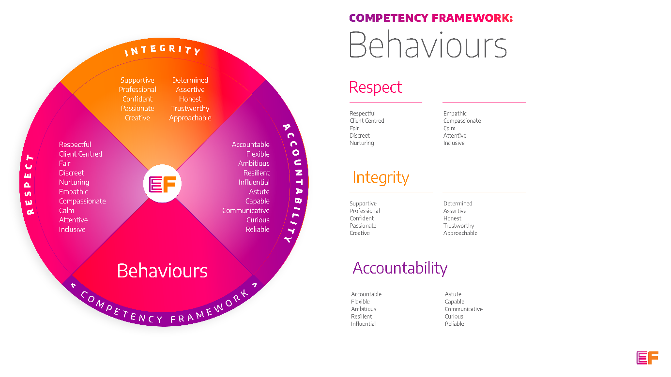  Accountability: taking purpose-driven action, owning our decisions, and remaining flexible as we grow.
Benefits: | - Minimum 25 days annual leave + bank holidays (pro rata for part time employees)  - Day off on your birthday every year  - Inclusive culture promoting innovation and autonomy  - Extensive Employee Assistance Programme including access to counselling, specialist advice and an online wellbeing portal  - Enhanced family friendly policies  - Emergency Financial Assistance policy  - Death In Service policy  - Pension scheme  - Option to purchase extra holidays  - Wellbeing hour  - CPD hour  - Cycle to Work Scheme  - Annual company events  - Extensive training package  - Support around personal and professional development

Principal Duties and Responsibilities

Leadership and Staff Management
- Support the wellbeing of all volunteers, mentors, advocates, and coaches within the partnership.

Communication, Representation and Engagement

- Promote the message of hope, recovery capital, visible assertive linkage, collaborative working, and meaningful reintegration into the community including engagement with mutual aid opportunities

- Work alongside other professionals in the MDT to provide support to named individuals as part of a coordinated support plan.

- Ensure your services are promoted through a variety of communications, marketing and media sources and platforms.

- Work closely with community-based projects and local facilitators in supporting engagement in focused activities.

- Ensure the profile of EF is raised at every opportunity and that examples of good practice are shared with the widest possible audience, including local employers, communities, and recovery communities.

Governance, Legal, Facilities and Risk

- Promote and ensure adherence to Equality of Opportunity policies and anti-discriminatory practice, demonstrating EF’s commitment to valuing diversity.

- To ensure that all staff (paid and unpaid) members understand and abide by relevant legislation, statutory policy and EF policies and procedures.

Service Delivery & Performance

- Working creatively to engage individuals who may not be in touch with mainstream services, those isolated in communities, unaware of services, or who do not feel services are for them.

- Engage individuals experiencing multiple disadvantages, with the aim of exploring their needs, and engaging them with the wider MDT.

- Provide a friendly and consistent space including 1:1 and group activities for individuals to engage in an informal way which is not overtly addressing recovery needs.

- Utilise your own personal experiences of homelessness, domestic abuse, substance misuse, mental health difficulties or contact with the criminal justice system to communicate with individuals, aid their engagement, show empathy and act as a role model.

- Undertake a training programme to develop skills and abilities required and actively taking part in your own personal development plan.

- Attend team meetings/group supervision with the aim of sharing good practice and finding solutions.

- Gain feedback from individuals on their experience of services and feedback to the central programme team, either formally, as case studies or as informal feedback.

Other

- You will be required to work flexibly from varying operational sites as required and agreed with line manager.

- A willingness to work some evenings/weekends as required.

- Commitment to continued personal development, maintaining an up-to-date knowledge of developments across the field, legislation and practice relevant to the service user group.

Generic Duties & Responsibilities
Confidentiality
Service user, volunteer and/or staff information is confidential. It is a condition of employment that you will not use or disclose any confidential information obtained in accordance with data protection legislation.
Code of Conduct
All staff are expected to adhere to all EF’s policies and procedures that establish standards of good practice and follow any codes of conduct which are relevant to their own profession.
Privacy & Dignity
Staff should respect service user/family/carer’s diversity, cultural needs and privacy.
Safeguarding
All staff have a duty to safeguard and promote the welfare of service users, volunteers, their families and carers, you have a duty to ensure you are familiar with safeguarding policies, attend training for safeguarding and know who to contact if you have concerns about an adult or child’s welfare.
Health & Safety
Emerging Futures has a duty of care to employees and will ensure that, as far as is reasonably practicable, adequate training, facilities and arrangements for risk avoidance are in place. All employees are required to comply with relevant Health and Safety legislation and policies relating to Health & Safety and Risk Management

Educational Requirements & Competency Framework

These are the education requirements and competencies required for this role. Please demonstrate in your application where you meet the requirements and where you may need additional support and training.

ESSENTIAL | DESIRABLE
Education & Experience  Experience of delivering psychotherapeutic groups to those contemplating change and sustained changes in drug and/or alcohol use, criminal behaviour, and social functioning.  Experience of providing peer support on a voluntary basis. | Education & Experience  PTTLS or equivalent qualification.

