Document: | Job Description and Person Specification
Job Title: | Housing Project Worker
Project Base: | Emerging Futures, West Sussex
Hours & Salary: | 15.5 hours – £8,684
Accountable to: | Housing Manager
Job Summary: | You will be employed as part of a designated housing team providing housing and recovery support to people who are resident in Emerging Futures West Sussex housing services, providing a safe and homely environment to encourage positive change.  Using Housing First and harm reduction techniques, you will be assessing need and risk, providing tenancy, budgeting, and general living skills support. You will be assisting residents to achieve their individual goals and create move on plans suited to their needs.  Working within a Psychologically and Trauma Informed Environment you will be responsible for case coordination of individuals residing in the project and the provision of both opportunistic and structured interventions.  Working closely with probation, CGL and other key stakeholders, you will be providing an opportunity for our service users to make positive changes, build recovery capital and establish positive connections within their community, enabling them to lead fuller and healthier lives, free from substance use and crime, in turn supporting safer communities.

Document: | Job Description and Person Specification
Values: | Our values  Respect: listening to people and treating them with dignity.  Integrity: being honest and open (with each other) and providing a voice for those who are expert by experience.  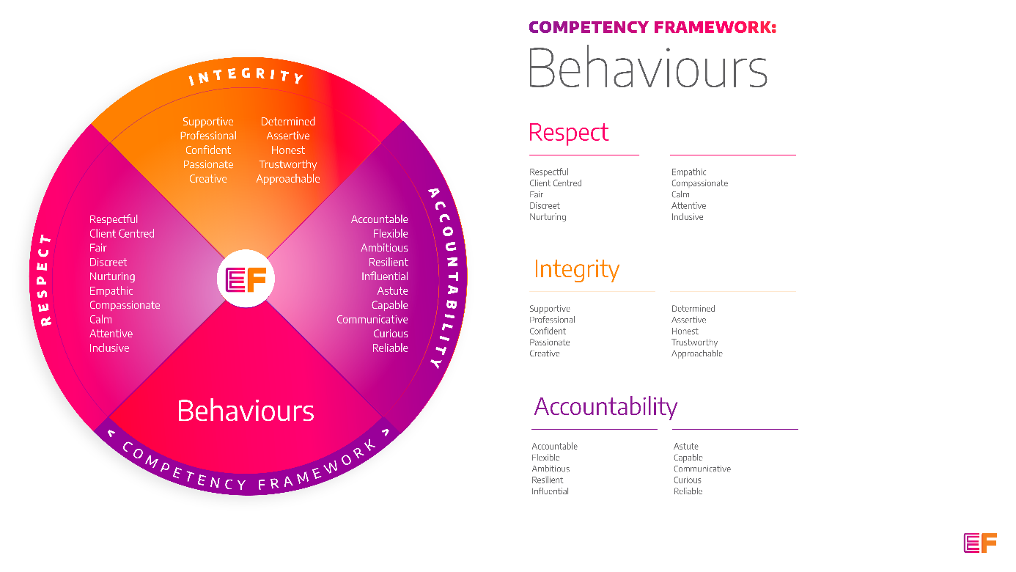  Accountability: taking purpose-driven action, owning our decisions, and remaining flexible as we grow.
Benefits: | - Minimum 25 days annual leave + bank holidays (pro rata for part time employees)  - Day off on your birthday every year  - Inclusive culture promoting innovation and autonomy  - Extensive Employee Assistance Programme including access to counselling, specialist advice and an online wellbeing portal  - Enhanced family friendly policies  - Emergency Financial Assistance policy  - Death In Service policy  - Pension scheme  - Option to purchase extra holidays  - Wellbeing hour  - CPD hour  - Cycle to Work Scheme  - Annual company events  - Extensive training package  - Support around personal and professional development

Principal Duties and Responsibilities

Leadership and Staff Management
- Provide support to Emerging Futures trained Recovery Coaches.

Communication, Representation and Engagement

- To ensure the profile of EF is raised at every opportunity and that examples of good practice are shared with the widest possible audience, including local employers, communities, and recovery communities.

- Ensure your services are promoted through a variety of communications, marketing and media sources and platforms.

- Build and maintain active relationships with local groups and businesses to continuously create and maintain opportunities for positive activity for service users during and after leaving treatment interventions, abstinence programmes and community outreach services.

- Take an active role in the wider community and create opportunities for partnership working to make recovery visible, viable and an attractive option for all.

Governance, Legal, Facilities and Risk

- To ensure all EF’s risk management and quality assurance policies are implemented and staff (paid and unpaid) understand and adhere to EF’s policies and procedures.

- To ensure the safety of all tenants and service users and maintain awareness of risks and changes in the working environment and contribute to the maintenance and monitoring of health and safety and security policies, systems, and protocols.

- Uphold data protection legislation and only share client information as per EF policy, local and formally agreed information sharing protocols and client confidentiality agreements.

- Promote and ensure adherence to Equality of Opportunity policies and anti-discriminatory practice, demonstrating EF’s commitment to valuing diversity.

- Maintain up to date and concise case notes using a variety of case management systems.

Finance
- To collect, record and bank rent, and other incomes received by tenants.

- To complete financial planning with residents including rent collection and monitor non-payment of rent and act in line with the agreed policy and procedures. Provide debt counselling where appropriate.

Service Delivery & Performance

- Ensure residents understand their tenancy agreement, their rights and obligations and report any breaches to management.

- Support tenants to maintain their tenancy by providing hands on, practical help and advice across our network of supported housing.

- Controlling, accessing, facilitating, and monitoring housing visits from contractors and other visitors/professionals.

- Provide tenancy sustainment support to reduce the likelihood of eviction and homelessness.

- Case Coordination of residents including assessment, recovery & life planning.

- Delivery of a range of structured and opportunistic psychosocial interventions to prevent reoffending or promote sustained and improved wellbeing.

- Complete incident reports as and when required to a high quality.

- Periodic inspections of Emerging Futures housing in conjunction with your line manager and arranging for any repairs or improvements to be carried out, including the replacement of furniture.

- Undertake accurate and comprehensive assessments of need, identifying levels of risk, recovery potential and to establish immediate and longer-term recovery goals.

Other

- You will be required to work flexibly from varying operational sites as required and agreed with line manager.

- A willingness to work some evenings/weekends as required.

- Commitment to continued personal development, maintaining an up-to-date knowledge of developments across the field, legislation and practice relevant to the service user group.

Generic Duties & Responsibilities
Confidentiality
Service user, volunteer and/or staff information is confidential. It is a condition of employment that you will not use or disclose any confidential information obtained in accordance with data protection legislation.
Code of Conduct
All staff are expected to adhere to all EF’s policies and procedures that establish standards of good practice and follow any codes of conduct which are relevant to their own profession.
Privacy & Dignity
Staff should respect service user/family/carer’s diversity, cultural needs and privacy.
Safeguarding
All staff have a duty to safeguard and promote the welfare of service users, volunteers, their families and carers, you have a duty to ensure you are familiar with safeguarding policies, attend training for safeguarding and know who to contact if you have concerns about an adult or child’s welfare.
Health & Safety
Emerging Futures has a duty of care to employees and will ensure that, as far as is reasonably practicable, adequate training, facilities and arrangements for risk avoidance are in place. All employees are required to comply with relevant Health and Safety legislation and policies relating to Health & Safety and Risk Management

Educational Requirements & Competency Framework

These are the education requirements and competencies required for this role. Please demonstrate in your application where you meet the requirements and where you may need additional support and training.

ESSENTIAL | DESIRABLE
Education & Experience  Experience, through paid or voluntary roles, of supporting individuals to make change.  Knowledge of substance misuses, homelessness, criminal justice sector or mental health.  An understanding of the harmful effects associated with drug and alcohol misuse and offending in relation to health, social welfare, housing, employability, and personal relationships. | Education & Experience  Coaching/counselling/Health and Social Care qualification.  Housing management or experience of working in the housing sector with vulnerable people.

