Document: | Job Description and Person Specification
Job Title: | Floating Support Worker
Project Base: | Emerging Futures, Manchester
Hours & Salary: | 26.5 hours – £23,979 - £25,584 pro rata
Accountable to: | Team Leader
Job Summary: | You will be employed as part of a specialist floating support team working with people experiencing substance misuse issues who are also at risk of eviction/homelessness or struggling to engage meaningfully with services.  The role will involve working with people with coexisting and complex issues, and you will be responsible for identifying support needs and managing a referral and assessment pathway. You will hold a caseload of clients to provide tenancy sustainment support and offer guidance to help navigate Manchester’s housing and treatment services.  You will be based across the city, working closely with CGL’s Manchester treatment provider and EF’s housing and network coach services, providing an in-reach service to a variety of settings and partner agencies, including night shelters, hostels, and temporary housing provisions. The role will involve developing an integrated, solution-focused pathway to ensure the reduction of any duplication by encouraging a collaborative approach and fostering effective working relationships with all other support providers in Manchester.  You will help to identify local community assets that can be utilised to enhance support or to establish wellbeing and meaningful activity in the community to:  - Improve access to suitable and sustainable accommodation.  - Reduce rates of unplanned discharges from drug and alcohol treatment.  - Deliver effective housing support interventions and ultimately reduce the scale of unmet housing need.

Document: | Job Description and Person Specification
Values: | Our values  Respect: listening to people and treating them with dignity.  Integrity: being honest and open (with each other) and providing a voice for those who are expert by experience.  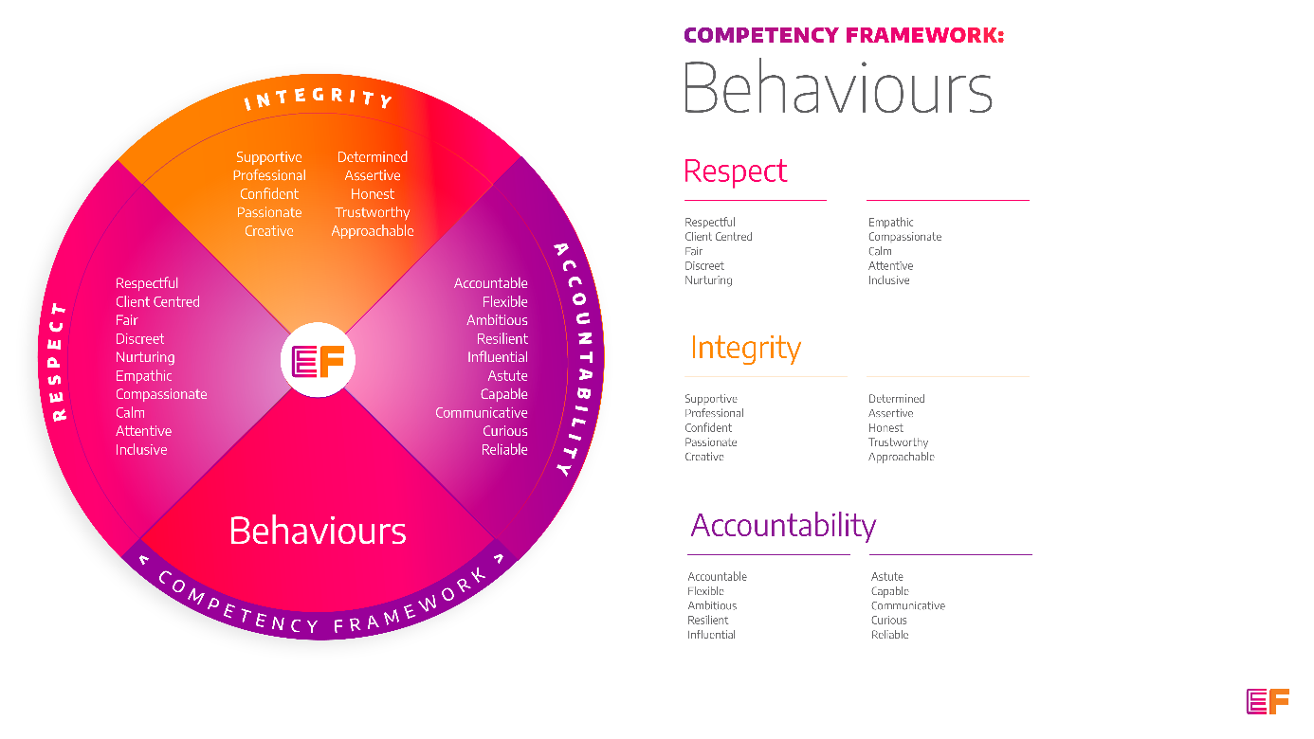  Accountability: taking purpose-driven action, owning our decisions, and remaining flexible as we grow.
Benefits: | - Minimum 25 days annual leave + bank holidays (pro rata for part time employees)  - Day off on your birthday every year  - Inclusive culture promoting innovation and autonomy  - Extensive Employee Assistance Programme including access to counselling, specialist advice and an online wellbeing portal  - Enhanced family friendly policies  - Emergency Financial Assistance policy  - Death In Service policy  - Pension scheme  - Option to purchase extra holidays  - Wellbeing hour  - CPD hour  - Cycle to Work Scheme  - Annual company events  - Extensive training package  - Support around personal and professional development

Principal Duties and Responsibilities

Leadership and Staff Management
- To provide coaching, wellbeing support and training to enable volunteers and Recovery Coaches to deliver their roles, grow and reach their fullest potential.

Communication, Representation and Engagement

- To ensure the profile of EF is raised at every opportunity and that examples of good practice are shared with the widest possible audience, including local employers, communities, and recovery communities.

- Develop and maintain excellent working links/partnerships with community agencies and resources, including faith-based groups, supported housing providers & training and educational providers.

- Assertive linkage with mental health/health services, CGL and housing/benefit related agencies, including attending appointments if necessary.

- Work with local communities, families, employers, and recovery communities to help the development and growth of local resources that support harm reduction, abstinence, wellbeing, and desistance.

- Engage service users in EF’s programmes, participate in on-going community resource mapping and asset-based community development.

Governance, Legal, Facilities and Risk

- Ensure all EF’s risk management and quality assurance policies are implemented and staff (paid and unpaid) understand and adhere to EF’s policies and procedures.

- Complete incident, accident reporting and safeguarding reporting where appropriate.

- Uphold data protection legislation and only share client information as per EF policy, local and formally agreed information sharing protocols and client confidentiality agreements.

- Ensure the safety of all tenants and service users and maintain awareness of risks and changes in the working environment and contribute to the maintenance and monitoring of health and safety and security policies, systems, and protocols.

- Promote and ensure adherence to Equality of Opportunity policies and anti-discriminatory practice, demonstrating EF’s commitment to valuing diversity.

Finance
- Complete financial planning with clients, assisting with the payment of rent arrangements, and monitoring non-payment of rent and acting in line with the agreed policy and procedures. Provide debt counselling where appropriate.

- Liaise with contacts from the Local Authority Housing Benefit department regarding tenants claims.

Service Delivery & Performance

- Manage the referral and assessment pathway between referral partners and Emerging Futures’ floating support service and community recovery housing.

- Provide tenancy sustainment support to reduce the likelihood of eviction and homelessness, in addition to ensuring service users are prepared to move forward towards independent living.

- Provide harm reduction techniques around substance misuse including preparation for change minimising alcohol use, safer injecting and advice on alternatives, poly drug use etc.

- Case coordination of service users including assessment, recovery & life planning, keywork and support planning.

- Provide a range of structured and opportunistic psychosocial interventions to prevent relapse and promote tenancy sustainment, improved wellbeing, and ‘SMART’ focused goal setting.

- Maintain up to date and concise case notes using a variety of case management systems.

Other

- You will be required to work flexibly from varying operational sites as required and agreed with line manager.

- A willingness to work some evenings/weekends as required.

- Commitment to continued personal development, maintaining an up-to-date knowledge of developments across the field, legislation and practice relevant to the service user group.

Generic Duties & Responsibilities
Confidentiality
Service user, volunteer and/or staff information is confidential. It is a condition of employment that you will not use or disclose any confidential information obtained in accordance with data protection legislation.
Code of Conduct
All staff are expected to adhere to all EF’s policies and procedures that establish standards of good practice and follow any codes of conduct which are relevant to their own profession.
Privacy & Dignity
Staff should respect service user/family/carer’s diversity, cultural needs and privacy.
Safeguarding
All staff have a duty to safeguard and promote the welfare of service users, volunteers, their families and carers, you have a duty to ensure you are familiar with safeguarding policies, attend training for safeguarding and know who to contact if you have concerns about an adult or child’s welfare.
Health & Safety
Emerging Futures has a duty of care to employees and will ensure that, as far as is reasonably practicable, adequate training, facilities and arrangements for risk avoidance are in place. All employees are required to comply with relevant Health and Safety legislation and policies relating to Health & Safety and Risk Management

Educational Requirements & Competency Framework

These are the education requirements and competencies required for this role. Please demonstrate in your application where you meet the requirements and where you may need additional support and training.

ESSENTIAL | DESIRABLE
Education & Experience  Experience of providing a range of evidence-based interventions to individuals affected by substance misuse and/or offending.  Experience of facilitating successful tenancy sustainment and working to achieve positive community connections.  Keyworker based experience of case management of individuals with a variety of complex needs and the ability to lone work.  Experience of working collaboratively with different partnership agencies. | Education & Experience  Coaching/counselling/Health and Social Care qualification.  Experience of managing staff or volunteers.

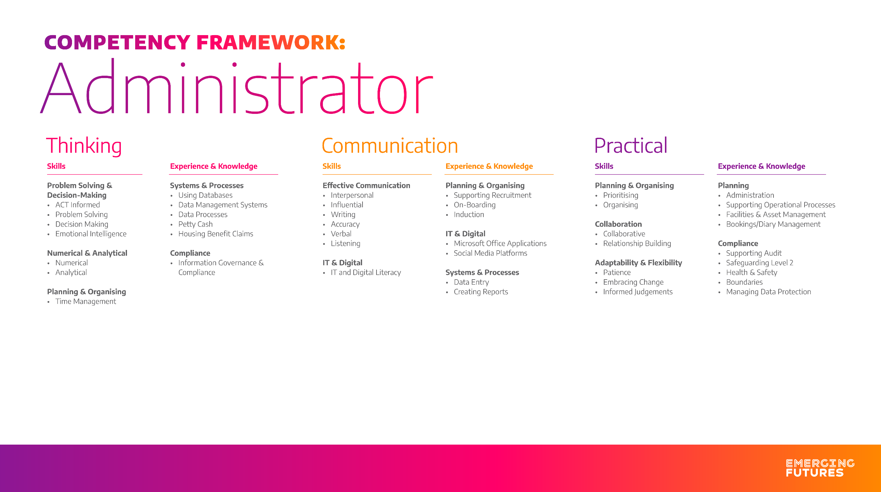

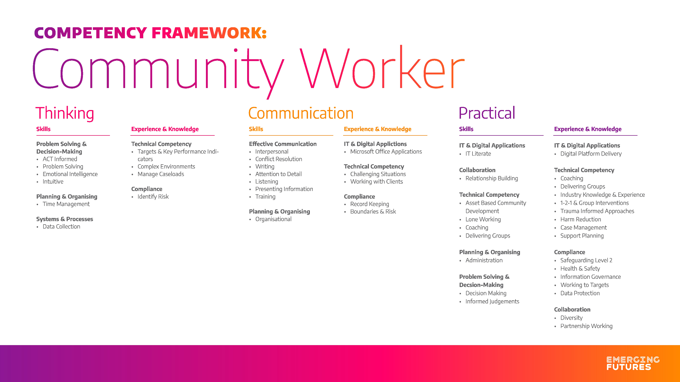
z

