Document: | Job Description and Person Specification
Job Title: | Criminal Justice Housing Support Worker
Project Base: | Emerging Futures, Hertfordshire
Hours & Salary: | 37.5 hours – £25,584
Accountable to: | Team Leader
Job Summary: | As a Criminal Justice Housing Support Worker, you will be providing housing and recovery support to people who have a history of substance and/or alcohol issues engaging with CGL - Spectrum Substance Misuse Service and who are experiencing accommodation problems. Working within a Psychologically Informed Environment you will be responsible for identifying individuals appropriate for recovery housing locally and managing the referral and assessment pathway.  For residents residing in Emerging Futures community recovery housing, you will provide case coordination and risk management and provide both opportunistic and structured interventions.  You will work closely with CGL Spectrum, local Emerging Futures recovery housing provision, partner organisations, housing, welfare and education and training providers to develop integrated, recovery infrastructures that engage, support, and navigate individuals from the vulnerability of addiction to established wellbeing and meaningful activity in the community.  In collaboration with CGL Spectrum you will support individuals through a detoxification pathway. This includes onward referrals to appropriate housing provision to enable those detoxing the best possible chance in a community setting.  It is essential you have a full driving licence and access to a car.

Document: | Job Description and Person Specification
Values: | Our values  Respect: listening to people and treating them with dignity.  Integrity: being honest and open (with each other) and providing a voice for those who are expert by experience.  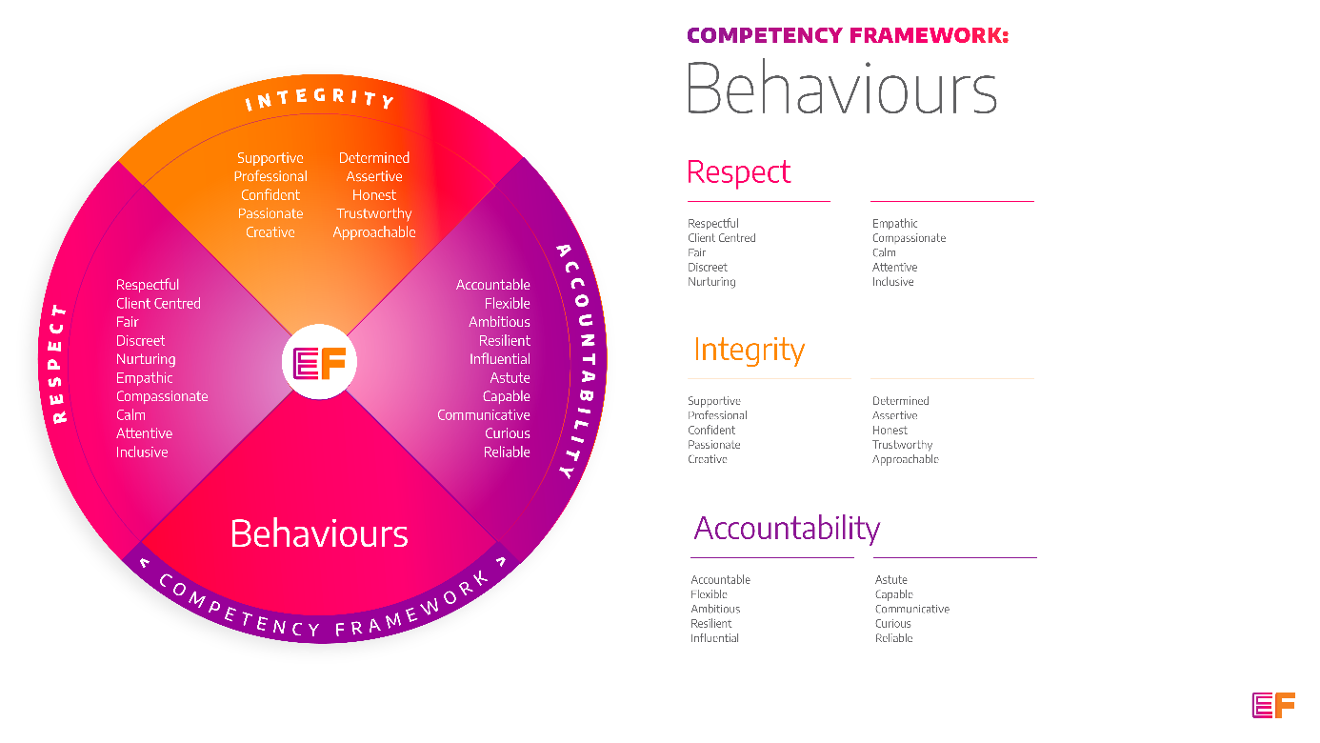  Accountability: taking purpose-driven action, owning our decisions, and remaining flexible as we grow.
Benefits: | - Minimum 25 days annual leave + bank holidays (pro rata for part time employees)  - Day off on your birthday every year  - Inclusive culture promoting innovation and autonomy  - Extensive Employee Assistance Programme including access to counselling, specialist advice and an online wellbeing portal  - Enhanced family friendly policies  - Emergency Financial Assistance policy  - Death In Service policy  - Pension scheme  - Option to purchase extra holidays  - Wellbeing hour  - CPD hour  - Cycle to Work Scheme  - Annual company events  - Extensive training package  - Support around personal and professional development

Principal Duties and Responsibilities

Leadership and Staff Management
- To provide coaching, wellbeing support and training to enable volunteers and Recovery Coaches to deliver their roles, grow and reach their fullest potential.

- To facilitate access to Mutual Aid, Asset Based Community Development and on-going Recovery Support.

Communication, Representation and Engagement

- To ensure the profile of EF is raised at every opportunity and that examples of good practice are shared with the widest possible audience, including local employers, communities and recovery communities.

- Ensure our services are promoted through a variety of communications, marketing and media sources and platforms.

- Oversee the development and delivery of EF’s programmes, participate in on-going community resource mapping and asset-based community development.

- Work with local communities, families, employers and recovery communities to help the development and growth of local resources that support harm reduction, abstinence, wellbeing and desistance.

Governance, Legal, Facilities and Risk

- To ensure all EF’s risk management and quality assurance policies are implemented and staff (paid and unpaid) understand and adhere to EF’s policies and procedures.

- To ensure the safety of all tenants and service users and maintain awareness of risks and changes in the working environment and contribute to the maintenance and monitoring of health and safety and security policies, systems and protocols.

- Within a delegated portfolio of services, ensure the effective implementation of serious untoward incident reporting in line with policy and procedures, and implementing lessons learned.

- Deal with issues and complaints raised by complying with EF’s complaints processes.

- Promote and ensure adherence to Equality of Opportunity policies and anti-discriminatory practice, demonstrating EF’s commitment to valuing diversity.

Finance
- To collect, record and bank rent and other incomes received by tenants.

- To complete financial planning with residents including rent collection and monitor non-payment of rent and act in line with the agreed policy and procedures. Provide debt counselling where appropriate.

- Liaise with colleagues from the Local Authority Housing Benefit department regarding tenants claims.

Service Delivery & Performance

- Manage the referral and assessment pathway between referral partner and Emerging Futures community recovery housing.

- Provide specialist housing related support to individuals identified within CGL Spectrum

- Provide tenancy sustainment support to reduce the likelihood of eviction and homelessness

- Ensure the safety and wellbeing of residents residing in community recovery housing including effective risk management.

- Case Coordination of residents including assessment, recovery & life planning, keywork and support planning.

- Provide a range of structured and opportunistic psychosocial interventions to prevent relapse or promote sustained and improved wellbeing.

- Complete incident, accident reporting and safeguarding reporting.

Other

- You will be required to work flexibly from varying operational sites as required and agreed with line manager.

- A willingness to work some evenings/weekends as required.

- Commitment to continued personal development, maintaining an up-to-date knowledge of developments across the field, legislation and practice relevant to the service user group.

Generic Duties & Responsibilities
Confidentiality
Service user, volunteer and/or staff information is confidential. It is a condition of employment that you will not use or disclose any confidential information obtained in accordance with data protection legislation.
Code of Conduct
All staff are expected to adhere to all EF’s policies and procedures that establish standards of good practice and follow any codes of conduct which are relevant to their own profession.
Privacy & Dignity
Staff should respect service user/family/carer’s diversity, cultural needs and privacy.
Safeguarding
All staff have a duty to safeguard and promote the welfare of service users, volunteers, their families and carers, you have a duty to ensure you are familiar with safeguarding policies, attend training for safeguarding and know who to contact if you have concerns about an adult or child’s welfare.
Health & Safety
Emerging Futures has a duty of care to employees and will ensure that, as far as is reasonably practicable, adequate training, facilities and arrangements for risk avoidance are in place. All employees are required to comply with relevant Health and Safety legislation and policies relating to Health & Safety and Risk Management

Educational Requirements & Competency Framework

These are the education requirements and competencies required for this role. Please demonstrate in your application where you meet the requirements and where you may need additional support and training.

ESSENTIAL | DESIRABLE
Education & Experience  Experience of providing a range of evidence-based interventions to individuals affected by substance misuse and/or offending.  Housing management experience or experience of working in a residential setting with those with a history of substance misuse.  Facilitating successful tenancy sustainment and working to achieve positive community connections.  Key Worker based case management of individuals with a variety of complex needs and ability to lone work.  Excellent partnership working. | Education & Experience  Coaching/ counselling/ Health and Social Care qualification.  Experience of motivating and inspiring unpaid staff and establishing the values-based training and support they require to flourish both professionally and in their personal recovery journey.  Experience of delivering group-work and training.  Specialist harm reduction experience.

