Document: | Job Description and Person Specification
Job Title: | Housing Support Worker (Detox Provision)
Project Base: | Emerging Futures, Watford, Hertfordshire
Hours & Salary: | 37.5 hours – £26,597
Accountable to: | Team Leader
Job Summary: | You will be employed as part of a specialist housing support team within our detoxification and stabilisation project across Watford. Residents will be engaged with the local CGL nurse to complete their detox and you will support tenancy sustainment and aftercare initiatives. You will encourage the onward referral to other Emerging Futures housing provision post detox.  Working within a Psychologically Informed Environment you will be responsible for case coordination of individuals residing in the project and the provision of both opportunistic and structured therapeutic interventions.  Part of your role will include advocating for residents where appropriate, helping residents arrange and attend scheduled appointments, for example, their structured day programme, GP, Probation, and other substance misuse services.  EF engage closely with partner organisations, clinicians, social care providers, ETE providers and the community to develop integrated, recovery infrastructures that engage, support, and navigate individuals from the vulnerability of homelessness to established wellbeing and meaningful activity.  You will be required to work on a rolling rota covering days, evenings and weekends.

Document: | Job Description and Person Specification
Values: | Our values  Respect: listening to people and treating them with dignity.  Integrity: being honest and open (with each other) and providing a voice for those who are expert by experience.  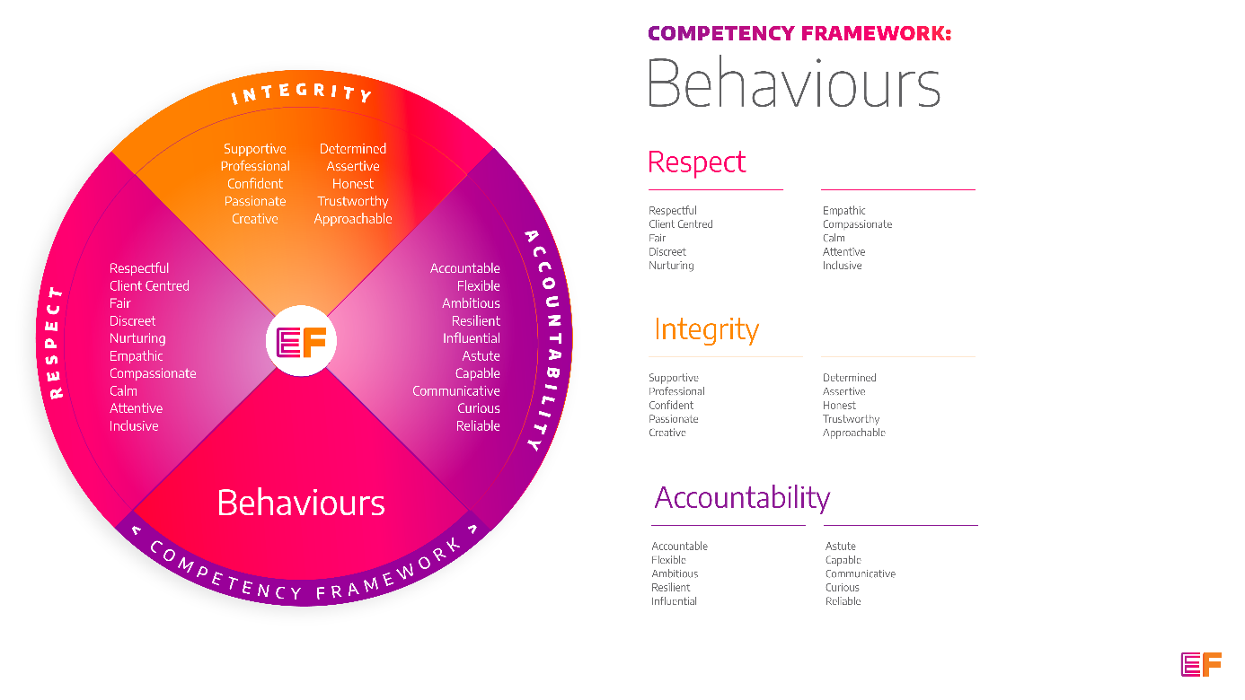  Accountability: taking purpose-driven action, owning our decisions, and remaining flexible as we grow.
Benefits: | - Minimum 25 days annual leave + bank holidays (pro rata for part time employees)  - Day off on your birthday every year  - Inclusive culture promoting innovation and autonomy  - Extensive Employee Assistance Programme including access to counselling, specialist advice and an online wellbeing portal  - Enhanced family friendly policies  - Emergency Financial Assistance policy  - Death In Service policy  - Pension scheme  - Option to purchase extra holidays  - Wellbeing hour  - CPD hour  - Cycle to Work Scheme  - Annual company events  - Extensive training package  - Support around personal and professional development

Principal Duties and Responsibilities

Leadership and Staff Management
- To provide coaching, wellbeing support and training to enable volunteers and Recovery Coaches to deliver their roles, grow and reach their fullest potential.

Communication, Representation and Engagement

- To ensure the profile of EF is raised at every opportunity and that examples of good practice are shared with the widest possible audience, including local employers, communities and recovery communities.

- Ensure our services are promoted through a variety of communications, marketing and media sources and platforms.

- Organise residents’ ‘house meetings’ and liaise, consult with, and actively support residents, encouraging participation in decision making processes wherever possible.

- Work with the Local Authority and other agencies to create move-on options and improve the health and wellbeing of tenants through direct 1-1 work.

- To support the development of recovery and employment initiatives for tenants across Hertfordshire, collaborating closely with local third sector and grass roots organisations, associations and individuals.

Governance, Legal, Facilities and Risk

- To ensure all EF’s risk management and quality assurance policies are implemented and staff (paid and unpaid) understand and adhere to EF’s policies and procedures.

- To ensure the safety of all tenants and service users and maintain awareness of risks and changes in the working environment and contribute to the maintenance and monitoring of health and safety and security policies, systems and protocols.

- Within a delegated portfolio of services, ensure the effective implementation of serious untoward incident reporting in line with policy and procedures, and implementing lessons learned.

- Deal with issues and complaints raised by complying with EF’s complaints processes.

- Promote and ensure adherence to Equality of Opportunity policies and anti-discriminatory practice, demonstrating EF’s commitment to valuing diversity.

Finance
- To complete financial planning with residents including rent collection and monitor non-payment of rent and act in line with the agreed policy and procedures. Provide debt counselling where appropriate.

- Liaise with contacts from the Local Authority Housing Benefit department regarding tenants claims.

Service Delivery & Performance

- Ensure residents understand their tenancy agreement, their rights and obligations and report any breaches to management.

- Deliver a range of structured and opportunistic psychosocial interventions to prevent relapse or promote sustained and improved wellbeing.

- Manage accommodation for individuals, enabling residents to access pathways to meet their more immediate needs before moving on to full independence, their own tenancies and meaningful activity.

- Monitor the provision of housing services (heating, cleaning, provision of furniture etc.).

- Transporting residents to and from their structured day programme.

- Ensure Hertfordshire services are accurately reported through the relevant systems, INFORM.

- Support tenants to maintain their tenancy by providing hands on, practical help and advice across our network of shared, supported housing.

- Regularly report all evidence, achievements, and concerns to the Team Leader.

- Observing client medication administration on a regular basis.

- Implement and manage systems to ensure residents are safe, meaningfully engaged and moving forward in their lives.

Other

- You will be required to work flexibly from varying operational sites as required and agreed with line manager.

- A requirement to work some evenings/weekends as required.

- You may be required to cover other local EF housing projects when required.

- Commitment to continued personal development, maintaining an up-to-date knowledge of developments across the field, legislation and practice relevant to the service user group.

Generic Duties & Responsibilities
Confidentiality
Service user, volunteer and/or staff information is confidential. It is a condition of employment that you will not use or disclose any confidential information obtained in accordance with data protection legislation.
Code of Conduct
All staff are expected to adhere to all EF’s policies and procedures that establish standards of good practice and follow any codes of conduct which are relevant to their own profession.
Privacy & Dignity
Staff should respect service user/family/carer’s diversity, cultural needs and privacy.
Safeguarding
All staff have a duty to safeguard and promote the welfare of service users, volunteers, their families and carers, you have a duty to ensure you are familiar with safeguarding policies, attend training for safeguarding and know who to contact if you have concerns about an adult or child’s welfare.
Health & Safety
Emerging Futures has a duty of care to employees and will ensure that, as far as is reasonably practicable, adequate training, facilities and arrangements for risk avoidance are in place. All employees are required to comply with relevant Health and Safety legislation and policies relating to Health & Safety and Risk Management

Educational Requirements & Competency Framework

These are the education requirements and competencies required for this role. Please demonstrate in your application where you meet the requirements and where you may need additional support and training.

ESSENTIAL | DESIRABLE
Education & Experience  Experience of providing a range of evidence-based interventions to individuals affected by homelessness, substance misuse and/or offending.  Experience of housing management or working in a residential setting with those with complex needs including challenging and/or negative behaviour.  Experience or an understanding of providing interventions that support individuals to develop their personal strengths within a ‘supported housing’ environment.  Experience of supporting individuals to initiate and sustain long term recovery and tenancy sustainment in the community.  Experience of developing partnerships and working collaboratively with other organisations and individuals. | Education & Experience  Coaching/ counselling/ Health and Social Care qualification.  Experience of motivating and inspiring unpaid staff and establishing the values-based training and support they require to flourish both professionally and in their personal recovery journey.  Experience of delivering group-work and training.  Specialist harm reduction experience.

