Document: | Job Description and Person Specification
Job Title: | Housing Support Worker
Project Base: | Emerging Futures, Swindon
Hours & Salary: | 37.5 hours – £22,509 - £24,775 p/a
Accountable to: | Team Leader
Job Summary: | As a Housing Support Worker, you will provide housing related support and recovery support for people who have a history of failed accommodation placement, substance and/or alcohol misuse, issues with mental health, criminality, and often challenging and negative behaviours. Working within a psychologically informed environment you will be responsible for case coordination of individuals residing in the project and the provision of both opportunistic and structured interventions.  Working with a blend of Housing First and harm reduction techniques, you will be assessing need, preparing tenancy support plans and supporting tenants to achieve their individual goals.  Initially based in Swindon but you may be required to work in other areas of the county as the housing provision expands.  Working flexibly on a rota basis, the role will involve covering evening shifts, waking night and weekends and public holidays.  Part of your role will include advocating for residents where appropriate, helping residents arrange and attend scheduled appointments, for example, GP, Probation, Job Centre, and substance misuse services.  EF engage closely with partner organisations, clinicians, social care providers, ETE providers and the community to develop integrated, recovery infrastructures that engage, support, and navigate individuals from the vulnerability of homelessness to established wellbeing and meaningful activity.

Document: | Job Description and Person Specification
Values: | Our values  Respect: listening to people and treating them with dignity.  Integrity: being honest and open (with each other) and providing a voice for those who are expert by experience.  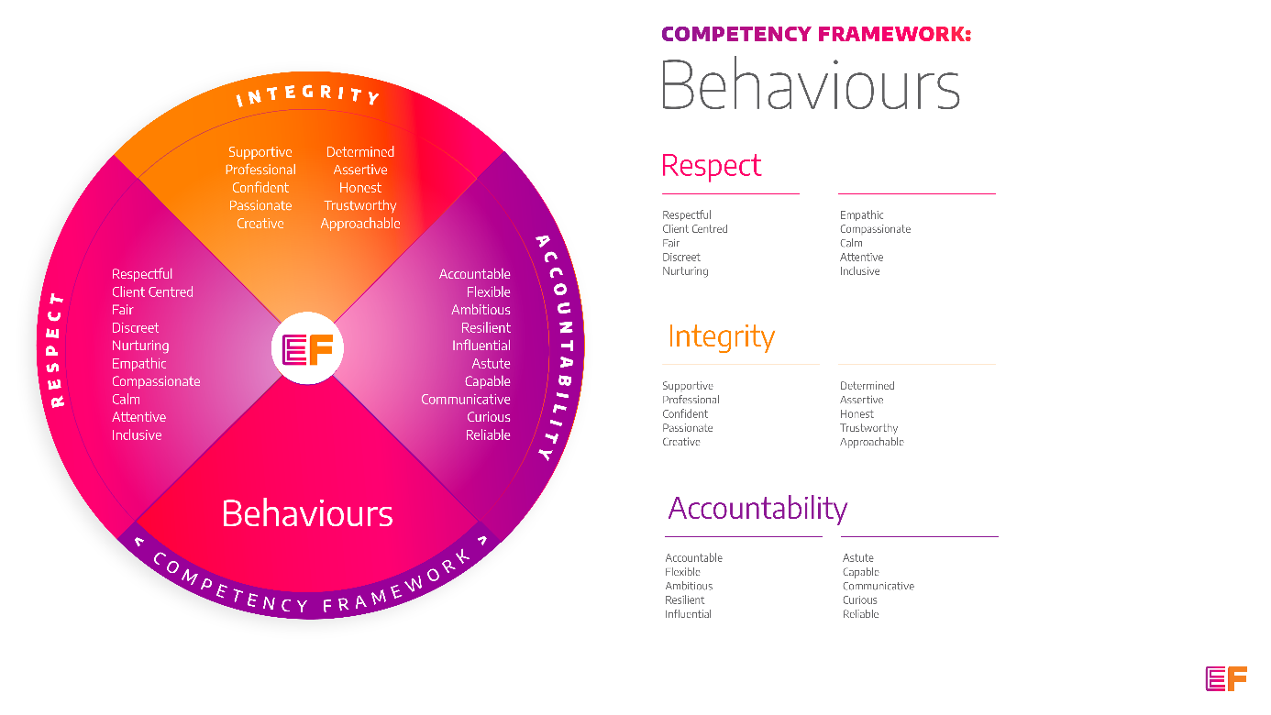  Accountability: taking purpose-driven action, owning our decisions, and remaining flexible as we grow.
Benefits: | - Minimum 25 days annual leave + bank holidays (pro rata for part time employees)  - Day off on your birthday every year  - Inclusive culture promoting innovation and autonomy  - Extensive Employee Assistance Programme including access to counselling, specialist advice and an online wellbeing portal  - Enhanced family friendly policies  - Emergency Financial Assistance policy  - Death In Service policy  - Pension scheme  - Option to purchase extra holidays  - Wellbeing hour  - CPD hour  - Cycle to Work Scheme  - Annual company events  - Extensive training package  - Support around personal and professional development

Principal Duties and Responsibilities

Service Delivery & Performance
- To facilitate access to Mutual Aid, Asset Based Community Development, and on-going Recovery Support.

- Ensure residents understand their tenancy agreement, their rights and obligations and report any breaches to management.

- Monitor the provision of housing services (heating, cleaning, provision of furniture etc.).

- Ensure Swindon services are accurately reported through the relevant and appropriate electronic systems, (INFORM and/or CRIIS etc)

- Regularly report all evidence, achievements and concerns to the Team Leader and Housing Manager.

- Support the implementation and management of systems to ensure residents are safe, meaningfully engaged and moving forward in their lives.

Communication, Representation and Engagement

- To ensure the profile of EF is raised at every opportunity and that examples of good practice are shared with the widest possible audience, including local employers, communities and recovery communities.

- Working closely with the Housing Manager and Team Leader, ensure our services are promoted through a variety of communications, marketing and media sources and platforms.

- Organise and help to facilitate residents’ ‘house meetings’ and liaise, consult with, and actively support residents, encouraging participation in decision making processes wherever possible.

- Contribute to the development and delivery of EF’s programmes, participate in on-going community resource mapping and asset-based community development.

- To support the development of recovery and employment initiatives for tenants across Swindon, collaborating closely with local third sector and grass roots organisations, associations and individuals

Safeguarding & Health and Safety

- To ensure all EF’s risk management and quality assurance policies are followed.

- To ensure the safety of all tenants and service users and maintain awareness of risks and changes in the working environment and contribute to the maintenance and monitoring of health and safety and security policies, systems and protocols.

- Working closely with the Team Leader and other team members, ensure the effective implementation of serious untoward incident reporting in line with policy and procedures, and implementing lessons learned.

- Assist in dealing with issues and complaints raised by complying with EF’s complaints processes.

- Promote and ensure adherence to Equality of Opportunity policies and anti-discriminatory practice, demonstrating EF’s commitment to valuing diversity.
Finance
- To collect, record and bank rent and other incomes received by tenants.

- To complete financial planning with residents including rent collection and monitor non-payment of rent and act in line with the agreed policy and procedures. Provide debt counselling where appropriate.

Other

- You will be required to work flexibly from varying operational sites as required and agreed with line manager.

- A willingness to work some evenings/weekends as required.

- Commitment to continued personal development, maintaining an up-to-date knowledge of developments across the field, legislation and practice relevant to the service user group.

Generic Duties & Responsibilities
Confidentiality
Service user, volunteer and/or staff information is confidential. It is a condition of employment that you will not use or disclose any confidential information obtained in accordance with data protection legislation.
Code of Conduct
All staff are expected to adhere to all EF’s policies and procedures that establish standards of good practice and follow any codes of conduct which are relevant to their own profession.
Privacy & Dignity
Staff should respect service user/family/carer’s diversity, cultural needs and privacy.
Safeguarding
All staff have a duty to safeguard and promote the welfare of service users, volunteers, their families and carers, you have a duty to ensure you are familiar with safeguarding policies, attend training for safeguarding and know who to contact if you have concerns about an adult or child’s welfare.
Health & Safety
Emerging Futures has a duty of care to employees and will ensure that, as far as is reasonably practicable, adequate training, facilities and arrangements for risk avoidance are in place. All employees are required to comply with relevant Health and Safety legislation and policies relating to Health & Safety and Risk Management

Educational Requirements & Competency Framework

These are the education requirements and competencies required for this role. Please demonstrate in your application where you meet the requirements and where you may need additional support and training.

ESSENTIAL | DESIRABLE
Education & Experience  Experience of providing a range of evidence-based interventions to individuals affected by homelessness, substance misuse and/or offending.  Experience of housing management or working in a residential setting with those with complex needs including challenging and/or negative behaviour.  Experience or an understanding of providing interventions that support individuals to develop their personal strengths within a ‘supported housing’ environment.  Experience of supporting individuals to initiate and sustain long term recovery and tenancy sustainment in the community.  Experience of developing partnerships and working collaboratively | Education & Experience  Coaching/ counselling/ Health and Social Care qualification.  Experience of delivering group-work and training.  Specialist harm reduction experience.

