Document: | Job Description and Person Specification
Job Title: | Housing Project Worker
Project Base: | Emerging Futures, Accrington
Hours & Salary: | 37.5 hours – £21,797 - £23,221
Accountable to: | Housing Team Leader
Job Summary: | As a Housing Project Worker, you will work within our housing model to provide housing and recovery support to women who have had a history of failed accommodation placement, substance and/or alcohol misuse, criminality and possibly challenging and negative behaviours, through to those who are abstinent and preparing for independence with the support of our recovery housing model.  Working within a Psychologically Informed Environment you will support the case coordination of individuals residing in the project and the provision of both opportunistic and structured interventions.  You will work closely with the staff team and partner organisations to develop integrated, recovery infrastructures that engage, support, and navigate individuals from the vulnerability of addiction to established wellbeing and meaningful activity in the community.  As part of a team of Project Workers, you will be assessing need, preparing tenancy support plans and supporting tenants to achieve their individual goals. In addition, be required to deliver structured interventions designed to support residents towards behaviours that support wellbeing and active citizenship and meaningful alternatives to problematic substance and alcohol use.  You will be required to work flexibility to suit the needs of the business and will be on a paid ‘on call’ rota to cover evenings and weekends.

Document: | Job Description and Person Specification
Values: | Our values  Respect: listening to people and treating them with dignity.  Integrity: being honest and open (with each other) and providing a voice for those who are expert by experience.  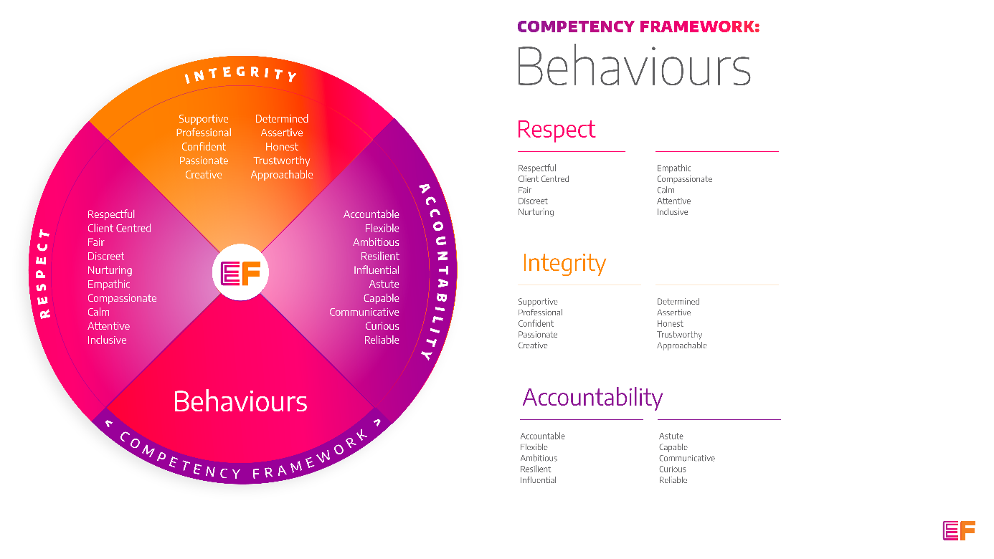  Accountability: taking purpose-driven action, owning our decisions, and remaining flexible as we grow.
Benefits: | - Minimum 25 days annual leave + bank holidays (pro rata for part time employees)  - Day off on your birthday every year  - Inclusive culture promoting innovation and autonomy  - Extensive Employee Assistance Programme including access to counselling, specialist advice and an online wellbeing portal  - Enhanced family friendly policies  - Emergency Financial Assistance policy  - Death In Service policy  - Pension scheme  - Option to purchase extra holidays  - Wellbeing hour  - CPD hour  - Cycle to Work Scheme  - Annual company events  - Extensive training package  - Support around personal and professional development

Principal Duties and Responsibilities

Leadership and Staff Management
- To support the team leader with coaching, wellbeing support and training to enable volunteers and recovery coaches to deliver their roles, grow and reach their fullest potential.

- To help to create progression pathways for volunteers & coaches and those on the pathway to employment programme.

Communication, Representation and Engagement

- To ensure the profile of EF is raised at every opportunity and that examples of good practice are shared with the widest possible audience, including local employers, communities, and recovery communities.

- Work with local communities, families, employers, and recovery communities to help the development and growth of local resources that support harm reduction, abstinence, wellbeing, and desistance.

- Develop and maintain excellent working links/partnerships with community agencies and resources, including faith-based groups, supported housing providers & training and educational providers.

- Oversee the development and delivery of EF’s programmes, participate in on-going community resource mapping and asset-based community development.

Governance, Legal, Facilities and Risk

- To ensure all EF’s risk management and quality assurance policies are implemented and staff (paid and unpaid) understand and adhere to EF’s policies and procedures.

- Promote and ensure adherence to Equality of Opportunity policies and anti-discriminatory practice, demonstrating EF’s commitment to valuing diversity.

- To ensure the safety of all tenants and service users and maintain awareness of risks and changes in the working environment and contribute to the maintenance and monitoring of health and safety and security policies, systems, and protocols.

Finance
- To collect and record rent and other incomes received by tenants.

- To complete financial planning with residents including rent collection and monitor non-payment of rent and act in line with the agreed policy and procedures. Provide debt counselling where appropriate.

- Liaise with colleagues from the Local Authority Housing Benefit department regarding tenants’ claims.

Service Delivery & Performance

- Escorting residents to appointments or on days out.

- Case Coordination of residents including assessment, recovery & life planning.

- Complete incident reports as and when required to a high standard.

- Deliver a range of structured and opportunistic psychosocial interventions to prevent relapse or promote sustained and improved wellbeing.

- Support the day to day running of the projects including group work delivery, health & safety, meal planning, residents’ meetings and resident move in plans.

- Maintain up to date and concise case notes using a variety of case management systems.

- Linkage and advocacy to mutual aid organisations locally as well as to wider community opportunities including education, sport, wellbeing, and volunteer opportunities

- Contribute to the establishment of a Psychologically Informed Environment for residents.

Other

- You will be required to work flexibly from varying operational sites as required and agreed with line manager.

- A willingness to work some evenings/weekends as required.

- Commitment to continued personal development, maintaining an up-to-date knowledge of developments across the field, legislation and practice relevant to the service user group.

Generic Duties & Responsibilities
Confidentiality
Service user, volunteer and/or staff information is confidential. It is a condition of employment that you will not use or disclose any confidential information obtained in accordance with data protection legislation.
Code of Conduct
All staff are expected to adhere to all EF’s policies and procedures that establish standards of good practice and follow any codes of conduct which are relevant to their own profession.
Privacy & Dignity
Staff should respect service user/family/carer’s diversity, cultural needs and privacy.
Safeguarding
All staff have a duty to safeguard and promote the welfare of service users, volunteers, their families and carers, you have a duty to ensure you are familiar with safeguarding policies, attend training for safeguarding and know who to contact if you have concerns about an adult or child’s welfare.
Health & Safety
Emerging Futures has a duty of care to employees and will ensure that, as far as is reasonably practicable, adequate training, facilities and arrangements for risk avoidance are in place. All employees are required to comply with relevant Health and Safety legislation and policies relating to Health & Safety and Risk Management

Educational Requirements & Competency Framework

These are the education requirements and competencies required for this role. Please demonstrate in your application where you meet the requirements and where you may need additional support and training.

ESSENTIAL | DESIRABLE
Education & Experience  Experience or an understanding of interventions that support individuals to develop their personal strengths within a ‘supported housing’ environment.  Experience of developing partnerships and working collaboratively with other organisations and individuals.  Experience of providing a range of evidence-based interventions to individuals affected by homelessness, substance misuse and/or offending. | Education & Experience  Coaching/ counselling/ Health and Social Care qualification.  Experience of motivating and inspiring unpaid staff and establishing the values-based training and support they require to flourish both professionally and in their personal recovery journey.  Experience of therapeutic community settings.

