Document Job Description and Person Specification
Job Title: | Team Leader (FRESH Project)
Project Base: | Emerging Futures, East and Central Lancashire
Hours & Salary: | 37.5 hours – £27,488- £29,193
Accountable to: | Service Manager
Criteria: | The role will require supporting and working with vulnerable female service users whom have been subjected to abuse and trauma-based experiences from males. The therapeutic programme, which will be delivered to service users whilst they are residents at a female only housing facility, will focus on the traumas that the female residents have experienced due to male perpetrators. As such, all applicants must be of the same sex as the residents. The role requires regular access to the housing facility with the vulnerable female residents living within the accommodation to deliver the programme, carry out visits and complete property checks which may involve lone work. As such to provide a safe, relaxed and therapeutic environment which facilitates recovery it is an occupational requirement that this role be undertaken by employees of the same sex as residents only.
Job Summary: | Emerging Futures Female Recovery Enhanced Supported Housing (FRESH) project provides a safe space for women to begin their recovery and behaviour change journey. Our projects will provide a safe, nurturing and homely environment, whilst building empathy, trust, and mutual understanding of each other’s experiences. Our staff team will provide bespoke and specialist trauma informed support to residents accessing the project.  As the Team Leader, you will be providing strong, visible operational leadership and direct line management to the team responsible for the delivery of the FRESH project.  Working with a blend of Housing First and harm reduction techniques you will be responsible for assessment, pre-tenancy work and case coordination of individuals in our satellite accommodation. You will take responsibility for the health and wellbeing of tenants, ensuring we are offering both opportunistic and structured interventions.  You will work closely with partner organisations, clinicians, social enterprises, education, and training providers to develop integrated recovery infrastructures that engage, support and navigate individuals from the vulnerability of homelessness and addiction to established wellbeing and meaningful recovery activity in the community.  You will be required to work flexibility to suit the needs of the business and will be on a paid ‘on call’ rota to cover evenings and weekends.

Document: | Job Description and Person Specification
Values: | Our values  Respect: listening to people and treating them with dignity.  Integrity: being honest and open (with each other) and providing a voice for those who are expert by experience.  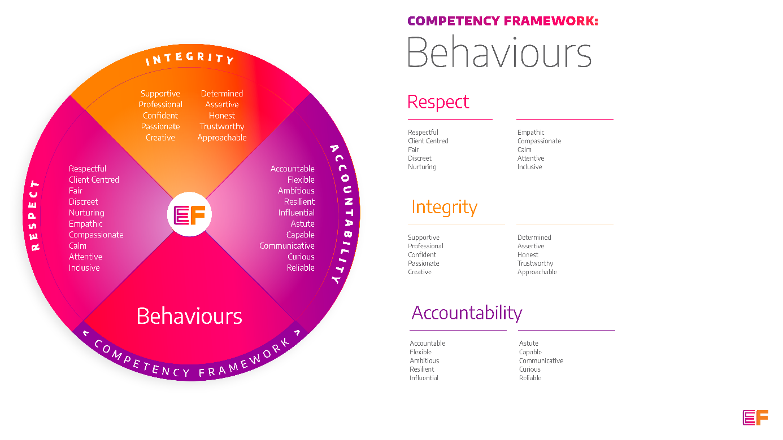  Accountability: taking purpose-driven action, owning our decisions, and remaining flexible as we grow.
Benefits: | - Minimum 25 days annual leave + bank holidays (pro rata for part time employees)  - Day off on your birthday every year  - Inclusive culture promoting innovation and autonomy  - Extensive Employee Assistance Programme including access to counselling, specialist advice and an online wellbeing portal  - Enhanced family friendly policies  - Emergency Financial Assistance policy  - Death In Service policy  - Pension scheme  - Option to purchase extra holidays  - Wellbeing hour  - CPD hour  - Cycle to Work Scheme  - Annual company events  - Extensive training package  - Support around personal and professional development

Principal Duties and Responsibilities

Leadership and Staff Management
- To ensure services are safely managed in line with the key deliverables.

- Hold managerial responsibility for the staff within your team to ensure a skill mix and ensure robust systems are in place for general and clinical supervision.

- To ensure services and activities are co-ordinated, efficiently managed and financial and human resources are maximised to ensure colleagues feel valued and able to work effectively.

- To provide coaching, wellbeing support, training and supervision to enable your team to deliver their roles, grow and reach their fullest potential.

- To ensure there are clear lines of accountability and responsibility across the team which foster and maintain effective working relationships for the organization.

- To manage all employee relations (HR) issues within your team and support the recruitment, induction and training of staff and professional volunteers.

Communication, Representation and Engagement

- To ensure the profile of EF is raised at every opportunity and that examples of good practice are shared with the widest possible audience, including commissioners, local employers, communities and recovery communities through a variety of communications, marketing and media sources and platforms.

- To manage internal communications to ensure that EF’s values are lived day-to- day, and potential for sharing and learning is maximised across the organisation.

- Oversee the development and delivery of EF’s programmes, participate in on-going community resource mapping and asset-based community development.

- To support the development of activity and employment initiatives for tenants across East Lancashire, collaborating closely with local third sector and grass roots organisations, associations and individuals.

- To facilitate access to Mutual Aid, Asset Based Community Development and on-going Recovery Support.
Governance, Legal, Facilities and Risk

- To ensure all EF’s risk management and quality assurance policies are implemented and staff (paid and unpaid) understand and adhere to EF’s policies and procedures.

- To ensure the safety of all staff, tenants and service users and maintain awareness of risks and changes in the working environment and contribute to the maintenance and monitoring of health and safety and security policies, systems and protocols.

- Ensure the effective implementation and compliance of serious untoward incident reporting in line with policy and procedures, carrying out investigations and implementing lessons learned.

- Deal with issues and complaints raised by complying with EF’s complaints processes.

- Promote and ensure adherence to Equality of Opportunity policies and anti-discriminatory practice, demonstrating EF’s commitment to valuing diversity.

Finance
- To be responsible for the overall financial management of petty cash, systems, rent collection and housing benefit payments including liaison with the Local Authority to ensure benefit claims are submitted and processed efficiently and effectively.

- To take appropriate steps to manage any financial risks that could impact on your services, staff and the overall organisation.

Service Delivery & Performance

- Ensure systems are in place to collate, monitor and report data, ensuring performance data, activity, opportunities and interventions are collated, recorded and reported accurately and in a timely manner and attend performance meetings as required.

- Ensure FRESH services are accurately reported through the relevant systems, INFORM and/or CRIIS.

- Empower your teams to capture additional data, local information, achievements and concerns which evidences quality across the organisation.

- Ensure all staff are aware of expectations and targets, offering support and guidance when necessary.

- Promote and encourage the utilisation of volunteers and coaching opportunities across Lancashire.

- Implement and manage systems to ensure residents are safe, meaningfully engaged and moving forward in their lives.

- Promote and support the wider implementation of Housing First and Psychologically Informed Environments across Lancashire.

Othe

- You will be required to work flexibly from varying operational sites as required and agreed with line manager.

- A willingness to work some evenings/weekends as required.

- Commitment to continued personal development, maintaining an up-to-date knowledge of developments across the field, legislation and practice relevant to the service user group.

Generic Duties & Responsibilities
Confidentiality
Service user, volunteer and/or staff information is confidential. It is a condition of employment that you will not use or disclose any confidential information obtained in accordance with data protection legislation.
Code of Conduct
All staff are expected to adhere to all EF’s policies and procedures that establish standards of good practice and follow any codes of conduct which are relevant to their own profession.
Privacy & Dignity
Staff should respect service user/family/carer’s diversity, cultural needs and privacy.
Safeguarding
All staff have a duty to safeguard and promote the welfare of service users, volunteers, their families and carers, you have a duty to ensure you are familiar with safeguarding policies, attend training for safeguarding and know who to contact if you have concerns about an adult or child’s welfare.
Health & Safety
Emerging Futures has a duty of care to employees and will ensure that, as far as is reasonably practicable, adequate training, facilities and arrangements for risk avoidance are in place. All employees are required to comply with relevant Health and Safety legislation and policies relating to Health & Safety and Risk Management

Educational Requirements & Competency Framework

These are the education requirements and competencies required for this role. Please demonstrate in your application where you meet the requirements and where you may need additional support and training.

ESSENTIAL | DESIRABLE
Education & Experience  Experience of managing complex needs, substance misuse and/or housing services.  Experience of managing adult social care and services within the third or public sector.  Experience of supporting women with specialist needs such as trauma, substance misuse, domestic abuse.  Experience of managing, developing and supporting staff in a challenging and demanding environment.  Experience of supporting individuals to initiate and sustain long term health gains, their own tenancy and recovery in the community.  Experience of developing partnerships and working collaboratively with other organisations. | Education & Experience  Management or equivalent qualification.  Experience of establishing and developing self-sustaining, recovery and harm reduction focused communities.  Experience of motivating and inspiring unpaid staff and establishing the values-based training and support they require to flourish both professionally.  Experience of delivering group-work and training.  Experience of managing outreach and/or community development services.  Specific experience of supporting staff with lived experience.

