Document: | Job Description and Person Specification
Job Title: | Community Connector
Project Base: | Emerging Futures, Central Lancashire
Hours & Salary: | 37.5 hours – £21,797 - £23,221
Accountable to: | Project Lead
Job Summary: | As a Community Connector you will be an integral part of a behaviour change team within North & Central Lancashire Inspire. The project will support individuals towards developing resilience and the capacity to live successful and fulfilling lives.  You will support individuals attempting to achieve and maintain their own recovery without the need for structured treatment. There will be a particular emphasis on developing recovery pathways for those entering and moving through treatment to sustain their recovery including the development and delivery of groups and recovery activities to enhance wellbeing, resilience, and positive behaviour change.  The role of a Community Connector involves the supervision of Network Coaches delivering the Foundations of Recovery programmes, in addition to supporting volunteer Recovery Coaches to create and deliver recovery-based support and activities.  You will have a particular focus on the mutually reciprocal relationship of our services and the local community and will work closely with those in recovery and local communities to develop a landscape that allows people to live well and thrive.  You will support the Project Lead to identify and train volunteer Coaches. You will support with the training, supervision, and deployment of coaches across the treatment system and local communities and supporting those Coached to deliver 1-1 Coaching interventions with families referred to the project.

Document: | Job Description and Person Specification
Values: | Our values  Respect: listening to people and treating them with dignity.  Integrity: being honest and open (with each other) and providing a voice for those who are expert by experience.  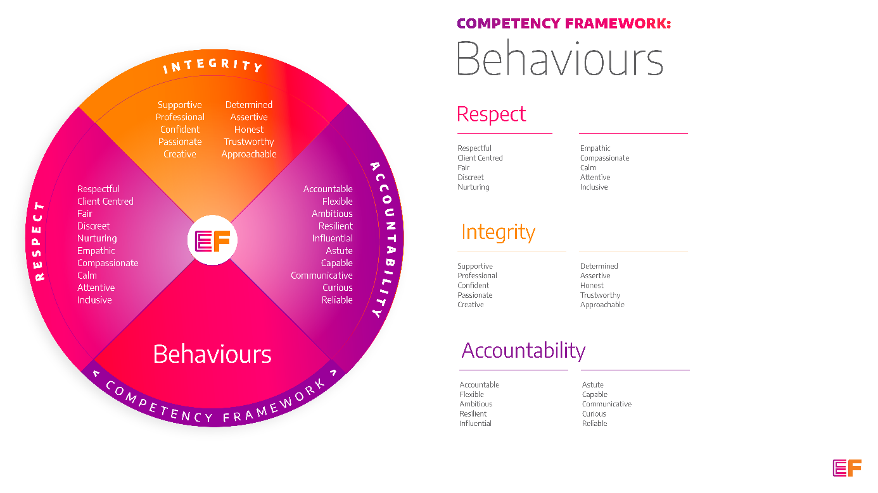  Accountability: taking purpose-driven action, owning our decisions, and remaining flexible as we grow.
Benefits: | - Minimum 25 days annual leave + bank holidays (pro rata for part time employees)  - Day off on your birthday every year  - Inclusive culture promoting innovation and autonomy  - Extensive Employee Assistance Programme including access to counselling, specialist advice and an online wellbeing portal  - Enhanced family friendly policies  - Emergency Financial Assistance policy  - Death In Service policy  - Pension scheme  - Option to purchase extra holidays  - Wellbeing hour  - CPD hour  - Cycle to Work Scheme  - Annual company events  - Extensive training package  - Support around personal and professional development

Principal Duties and Responsibilities

Leadership and Staff Management

- Supervise and support Network Coaches with the delivery of the Foundation of Recovery Model.

- Support the development of a Recovery Coaching model– including the recruitment, training, supervision and facilitation of groups/activities.

- Support the wellbeing of all volunteers, mentors, and coaches within the partnership.

Service Delivery & Performance
- Act as a route into treatment services by engaging with those that have substance misuse problems, providing them with immediate advice, screening, triage & risk information to address their substance misuse issues, and primary health care needs (including blood borne viruses).

- Support the Project Lead on the delivery of a range of specific interventions such as psychosocial group work, independent peer to peer support groups and networks such as ACT and family specific mutual aid that are self-sustaining and effective in supporting those moving away from addiction.

- Develop and deliver groups and recovery activities which will aid sustained recovery and improved wellbeing.

- Ensure that the program supports outcomes in a range of domains including wellbeing, social connectivity, employment, self-management, self-care, and psychological flexibility.

- Support the development of mutual aid and actively facilitate the attendance at mutual aid groups.

- Offer support & promote the benefits to service users who present with Long Term Health Conditions and educate & encourage them to see the benefits of referral to specialist services.

- Work within the wider behaviour change team to ensure the needs are addressed of those who may or may not need structured treatment.

- Maintain excellent case records and utilize case management and data collection tools.

Governance, Legal, Facilities and Risk

- Promote and ensure adherence to Equality of Opportunity policies and anti-discriminatory practice, demonstrating EF’s commitment to valuing diversity.

Communication, Representation and Engagement

- Work with local communities, employers, and recovery communities to help the development and growth of local resources that support recovery, wellbeing, desistance, and employment.

- Develop and maintain excellent working links/partnerships with community agencies and resources, including abstinence-based supported housing providers & treatment agencies.

- Ensure that the coaching program and other interventions meets the needs of diverse groups including the delivery of gender and BME specific groups and support for those with multiple complexities.

- Ensure your services are promoted through a variety of communications, marketing and media sources and platforms.

- To ensure the profile of EF is raised at every opportunity and that examples of good practice are shared with the widest possible audience, including local employers, communities, and recovery communities.

- Co-ordinate publicity, promotion and dissemination of information using a variety of mediums regarding North & Central Lancashire Services and the available opportunities to improve health and wellbeing. You will work within communities across localities to encourage the uptake of The “New You” Behaviour Change Team and Inspire Treatment Services by the diverse/underrepresented community groups.

Other

- You will be required to work flexibly from varying operational sites as required and agreed with line manager.

- A willingness to work some evenings/weekends as required.

- Commitment to continued personal development, maintaining an up-to-date knowledge of developments across the field, legislation and practice relevant to the service user group.

Generic Duties & Responsibilities
Confidentiality
Service user, volunteer and/or staff information is confidential. It is a condition of employment that you will not use or disclose any confidential information obtained in accordance with data protection legislation.
Code of Conduct
All staff are expected to adhere to all EF’s policies and procedures that establish standards of good practice and follow any codes of conduct which are relevant to their own profession.
Privacy & Dignity
Staff should respect service user/family/carer’s diversity, cultural needs and privacy.
Safeguarding
All staff have a duty to safeguard and promote the welfare of service users, volunteers, their families and carers, you have a duty to ensure you are familiar with safeguarding policies, attend training for safeguarding and know who to contact if you have concerns about an adult or child’s welfare.
Health & Safety
Emerging Futures has a duty of care to employees and will ensure that, as far as is reasonably practicable, adequate training, facilities and arrangements for risk avoidance are in place. All employees are required to comply with relevant Health and Safety legislation and policies relating to Health & Safety and Risk Management

Educational Requirements & Competency Framework

These are the education requirements and competencies required for this role. Please demonstrate in your application where you meet the requirements and where you may need additional support and training.

ESSENTIAL | DESIRABLE
Education & Experience  Experience of supporting individuals to initiate and sustain their own wellbeing in the community.  Experience of delivering psychotherapeutic groups.  Qualification in substance misuse or relevant qualification/experience.  Experience of delivering supervision to staff or volunteers. | Education & Experience  Experience of outreach work and community development.  Experience of delivering training.  PTTLS or equivalent qualification.

