Document: | Job Description and Person Specification
Job Title: | Network Coach – Substance Misuse
Project Base: | Emerging Futures, West Sussex
Hours & Salary: | 15.5 hours – £8,684
Accountable to: | Team Leader
Job Summary: | As a Network Coach, you will provide pre and post detox support across West Sussex. You will work across all projects including recovery from substance misuse, Housing, and Street Homelessness. Across the county of West Sussex, you will support individuals to transition into the community from structured treatment, detox, residential rehabilitation, and prison on behalf of Emerging Futures (EF) CIC.  You will contribute to the service to ensure that service users receive high quality services. You will contribute to the overall performance of the service to ensure that positive outcomes are achieved through working in a strength-based manner.  The duties of a Network Coach involve connecting individuals into recovery communities and mutual aid groups. You will identify recovery/wellbeing assets and resources within the wider community. As part of the role, you will be required to promote wellbeing and active citizenship; using your unique skills and experience to support others.  You will promote various options and routes into community based mutual aid and/or community reintegration through adult education, volunteering opportunities, employment, social enterprises, and community activities.

Document: | Job Description and Person Specification
Values: | Our values  Respect: listening to people and treating them with dignity.  Integrity: being honest and open (with each other) and providing a voice for those who are expert by experience.  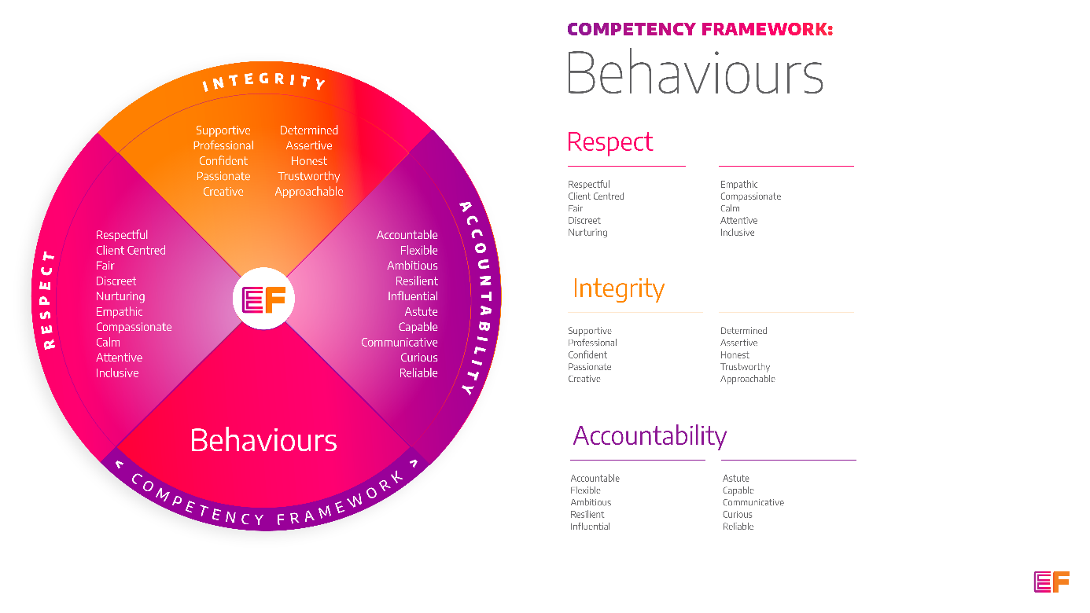  Accountability: taking purpose-driven action, owning our decisions, and remaining flexible as we grow.
Benefits: | - Minimum 25 days annual leave + bank holidays (pro rata for part time employees)  - Day off on your birthday every year  - Inclusive culture promoting innovation and autonomy  - Extensive Employee Assistance Programme including access to counselling, specialist advice and an online wellbeing portal  - Enhanced family friendly policies  - Emergency Financial Assistance policy  - Death In Service policy  - Pension scheme  - Option to purchase extra holidays  - Wellbeing hour  - CPD hour  - Cycle to Work Scheme  - Annual company events  - Extensive training package  - Support around personal and professional development

Principal Duties and Responsibilities

Leadership and Staff Management
- Support the wellbeing of all volunteers, mentors, advocates, and coaches within the partnerships we are involved in.

Service Delivery & Performance

- Establish professional, supportive relationships with those in recovery through support planning to create opportunities for sustained recovery in the community upon discharge from structured treatment.

- Identify aftercare pathways which assist service users in developing strong links with the greater community including mutual aid.

- Support local case managers in becoming aware of community recovery options in their Recovery Care Planning to provide a clear, purposeful ‘end point’ for service users in the community upon discharge from structured treatment.

- Alongside all Emerging Futures staff, promote the message of hope, recovery capital, visible assertive linkage, collaborative working, and meaningful reintegration into the community.

- Address any concerns service users may have with regards to engaging in community activities and provide support around this in a person-centred, strength-based manner.

- Creatively and actively identify/map local assets and initiate partnership working opportunities across West Sussex.

- Promote local mutual aid groups, providing support where necessary to attend these groups including priming, peer support and in-reach/assertive linkage.

- Actively support the involvement of families and support networks in service development and delivery.

Communication, Representation and Engagement

- To ensure the profile of EF is raised at every opportunity and that examples of good practice are shared with the widest possible audience, including local employers, communities, and recovery communities.

- Ensure your services are promoted through a variety of communications, marketing and media sources and platforms.

- Build and maintain active relationships with local groups and businesses to continuously create and maintain opportunities for positive activity for service users during and after leaving treatment interventions, abstinence programmes and community outreach services.

- Take an active role in the wider community and create opportunities for partnership working to make recovery visible, viable and an attractive option for all.

Governance, Legal, Facilities and Risk

- Promote and ensure adherence to Equality of Opportunity policies and anti-discriminatory practice, demonstrating EF’s commitment to valuing diversity.

Other

- You will be required to work flexibly from varying operational sites as required and agreed with line manager.

- A willingness to work some evenings/weekends as required.

- Commitment to continued personal development, maintaining an up-to-date knowledge of developments across the field, legislation and practice relevant to the service user group.

Generic Duties & Responsibilities
Confidentiality
Service user, volunteer and/or staff information is confidential. It is a condition of employment that you will not use or disclose any confidential information obtained in accordance with data protection legislation.
Code of Conduct
All staff are expected to adhere to all EF’s policies and procedures that establish standards of good practice and follow any codes of conduct which are relevant to their own profession.
Privacy & Dignity
Staff should respect service user/family/carer’s diversity, cultural needs and privacy.
Safeguarding
All staff have a duty to safeguard and promote the welfare of service users, volunteers, their families and carers, you have a duty to ensure you are familiar with safeguarding policies, attend training for safeguarding and know who to contact if you have concerns about an adult or child’s welfare.
Health & Safety
Emerging Futures has a duty of care to employees and will ensure that, as far as is reasonably practicable, adequate training, facilities and arrangements for risk avoidance are in place. All employees are required to comply with relevant Health and Safety legislation and policies relating to Health & Safety and Risk Management

Educational Requirements & Competency Framework

These are the education requirements and competencies required for this role. Please demonstrate in your application where you meet the requirements and where you may need additional support and training.

ESSENTIAL | DESIRABLE
Education & Experience (paid or unpaid)  An understanding/experience of recovery as a concept as well as the range of recovery pathways available in the community and support individuals to find their own pathway.  Experience of supporting individuals to initiate and sustain behaviour change that increases safety and wellbeing. | Education & Experience  Coaching or counselling qualification.  Evidence of working in a cooperative partnership approach.  Completed Emerging Futures accredited 5-day Recovery Coach training.

